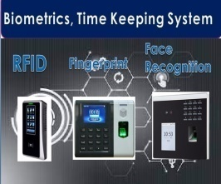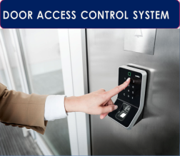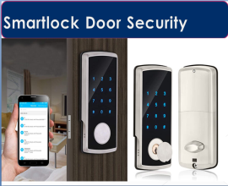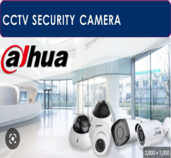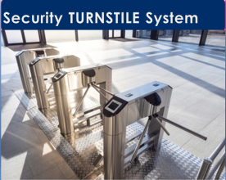

Quote Ref No: 2025-JK-X
Date | Claude, automatically put today’s date here thanks | Contact Person | Contact Person Goes Here
Client | Company Name Goes Here | Contact Number
Address | Address Goes Here | Email

Thank you for your interest in our products; we will assist you with selecting the best systems & solutions that would fit your requirements.

- GRANDING - FA110 - FACE & FINGERPRINT
Model | Item Description | Qty | Unit | Unit Price | PROMO AMOUNT | TOTAL  AMOUNT
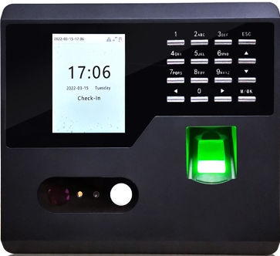  FA110 | ~ 2.8 Inch TFT Screen  ~ 500 Face Capacity  ~ 500 fingerprint templates capacity  ~ 50,000 transaction logs capacity  ~network//USB Host/ WIFI  ~Standard Function DSLT, Scheduled bell, Self Service Query, Automatic status switch, Photo Id  Adms  ~ Dimension: 161x93x152  ~ 36 MONTHS WARRANTY | 2 | pc | ₱17,900.00 | ₱9,700.00 | ₱19,400.00
Software | ZkTeco Attendance Management | 2 | License | Free | Free | Free
 | 16GB USB FLASH DISK DRIVE | 2 | pc | Free | Free | Free

OPTIONAL ACCESSORIES
Model | Item Description | Qty | Unit | Unit Price | PROMO AMOUNT
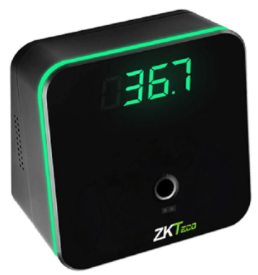  TMD95E | Model: TDM95E  Communication: USB 1.1  USB: Type-C  Temperature Detection: Distance 3 - 5cm  Temperature: Unit °C or °F  Temperature: Measurement Range 32.0°C - 42.9°C / 89.6°F - 109.22°F  Temperature Measurement Deviation: ±0.3°C / ±0.54°F  Digital Display: Tube 4  Operating Voltage: 5V  Operating Temperature: 15°C - 35°C / 59°F - 95°F  Operating Humidity: 10% - 85%  Dimensions: 88 * 88 * 54.63 (mm)  Weight of the Device: 0.17kg  Weight of the Device with Packaging: 0.29kg | 1 | pc | ₱9,500.00 | ₱9,500.00
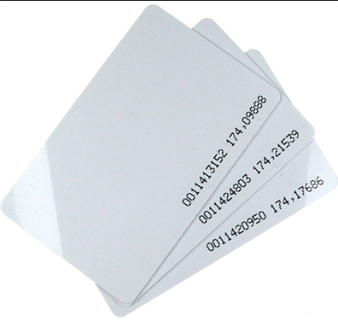 | Proximity Card 125khz(Thin) | 1 | pc | ₱P80.00 | ₱80.00
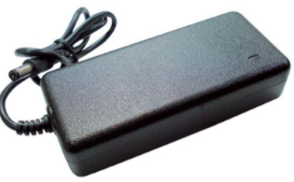 | 5v Mini Ups | 1 | pc | ₱2,500.00 | ₱2,500.00
 | 12v Mini Ups | 1 | pc | ₱3,500.00 | ₱3,500.00

CONFORME
BY
Signature Over Printed Name/Date

TERMS & CONDITIONS:
1.) Prices quoted above are VAT Exclusive. Email or fax certification if your company is vat exempt and zero rated for billing preparation.
2.) Prices are subject to change without prior notice. Validity for this quotation is 15 days from the date stated above.
3.) Payment terms is Fifty Percent (50%) upon P.O. or signing of this CONFORME. Remaining balance shall be paid upon receive of items or after the installation.
4. Payment will be accepted in CASH, COD, and Dated Check or thru Bank Transfer payable to TECHFINITY SECURITY DEVICE TRADING.
5. FREE DELIVERY for purchases above Php10, 000 within Metro Manila, otherwise additional Php 500 delivery fee depending on location.
6. Cancelled orders are subject to a cancellation charge of Fifty Percent (50%).
7. Up to three (3) years limited warranty in service and parts will be given for main equipment from date of purchase/delivery/installation. Accessories such as power supply, adaptor, magnetic lock, exit button have six (6) months warranty. The warranty covers the parts cause of factory defect not including upgrades and relocation. Unauthorized repair will void its warranty. Warranty claims is strictly carried in basis, client must send the item to our office for repair. For those with installation, we will do the onsite checking and troubleshooting for free within metro manila, for outside metro manila client will pay for the mobilization/demobilization cost.
8. Should client will require service unit while defective device is under repair; client must pay a service unit fee but depends on the availability of the service unit.
9. After sales support is from Monday – Friday 8:30 – 5:30 pm
Best Regards
JOHN KARL NOLASCO
Sales Account Officer
09484263778

